

**\*Communication department logo\***

**Smart Car Parking System**

**by: -**

Mohamed Nageh

Mohamed Gamal Hamed

Mohamed Hany Hassan

Abdelrahman Mohamed El-mahdy

Mohamed Fadl Sholkamy

# Supervisors: -

# Dr\ Nabil Abd rabou

# Eng\ Esraa Abdelhady

**Introduction: -**

There is no doubt that parking problems are ones of the biggest problems nowadays, Parking issues starts from searching for hours just to find free parking slot and sometimes can be as worse as finding out that all parking slots are full.

**Our smart parking system offers solutions for these problems by providing the following features: -**

* Only opens if there are free parking slots
* Tells the client which parking slots are free
* Alert clients if a car is leaving (when parking is full)
* Calculate parking price and show it to clients on their way out

**Hardware components: -**

**1. Arduino uno R3**

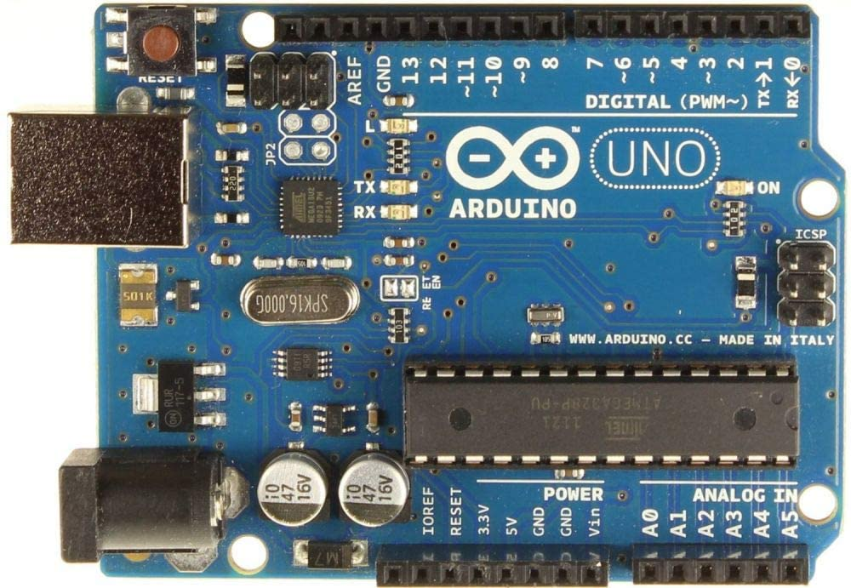

**Features: -**

**1. Processor:**

* ATMega328P Processor

**2. Memory:**

* AVR CPU at up to 16 MHz
* 32KB Flash
* 2KB SRAM
* 1KB EEPROM

**3. Security:**

* Power On Reset (POR)
* Brown Out Detection (BOD)

**Peripherals:-**

* 2x 8-bit Timer/Counter with a dedicated period register and compare channels
* 1x 16-bit Timer/Counter with a dedicated period register, input capture and compare channels 1x USART with fractional baud rate generator and start-of-frame detection
* 1x controller/peripheral Serial Peripheral Interface (SPI)
* 1x Dual mode controller/peripheral I2C
* 1x Analog Comparator (AC) with a scalable reference input
* Watchdog Timer with separate on-chip oscillator
* Six PWM channels Interrupt and wake-up on pin change

**Power consumption: -**

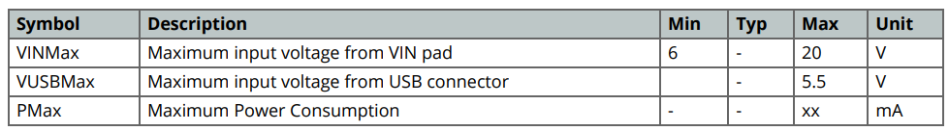

**Board topology: -**

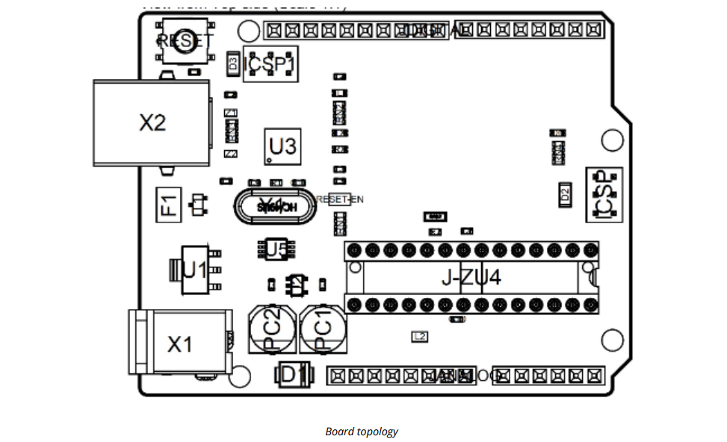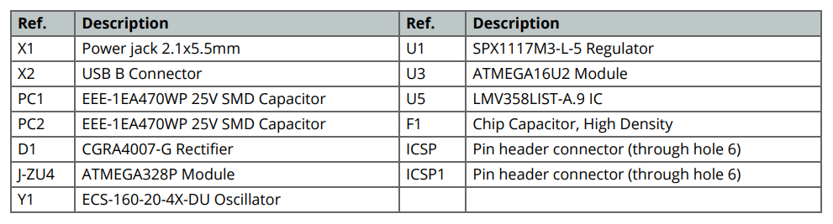

**Power Tree: -**

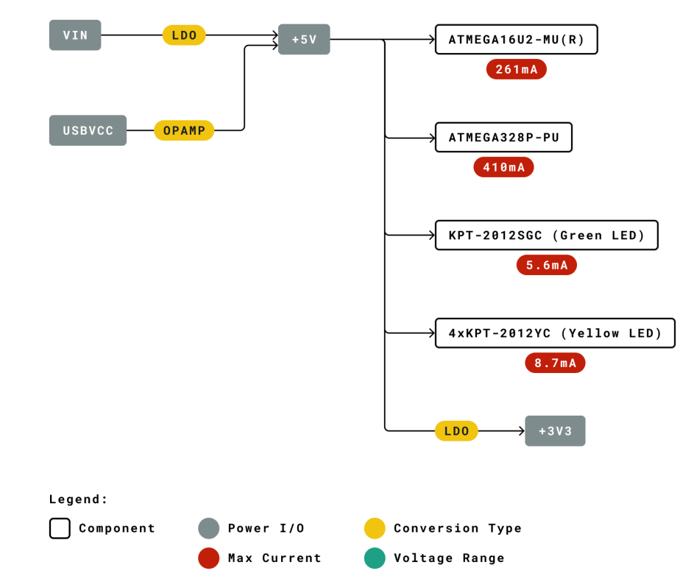

**Processor: -**

The Main Processor is a ATmega328P running at up tp 20 MHz. Most of its pins are connected to the external headers, however some are reserved for internal communication with the USB Bridge coprocessor.

**Board Operation: -**

**1. Getting Started - IDE**

If you want to program your Arduino UNO while offline you need to install the Arduino Desktop IDE [1] To connect the Arduino UNO to your computer, you’ll need a Micro-B USB cable. This also provides power to the board, as indicated by the LED.

**2. Getting Started - Arduino Web Editor**

All Arduino boards, including this one, work out-of-the-box on the Arduino Web Editor [2], by just installing a simple plugin. The Arduino Web Editor is hosted online, therefore it will always be up-to-date with the latest features and support for all boards. Follow [3] to start coding on the browser and upload your sketches onto your board.

**3. Getting Started - Arduino IoT Cloud**

All Arduino IoT enabled products are supported on Arduino IoT Cloud which allows you to Log, graph and analyze sensor data, trigger events, and automate your home or business.

**4. Sample Sketches**

Sample sketches for the Arduino XXX can be found either in the “Examples” menu in the Arduino IDE or in the “Documentation” section of the Arduino Pro website [4]

**5. Online Resources**

Now that you have gone through the basics of what you can do with the board you can explore the endless possibilities it provides by checking exciting projects on ProjectHub [5], the Arduino Library Reference [6] and the online store [7] where you will be able to complement your board with sensors, actuators and more

**6. Board Recovery**

All Arduino boards have a built-in bootloader which allows flashing the board via USB. In case a sketch locks up the processor and the board is not reachable anymore via USB it is possible to enter bootloader mode by doubletapping the reset button right after power up

**Connector Pinouts: -**

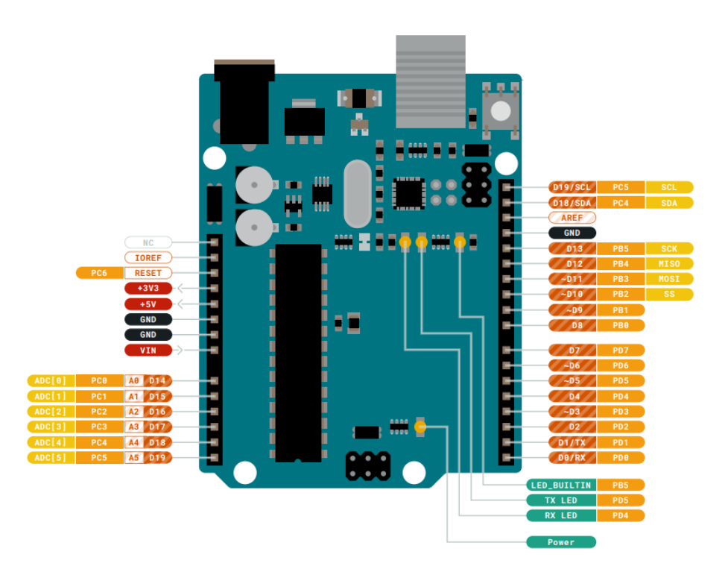

**1. JANALOG**

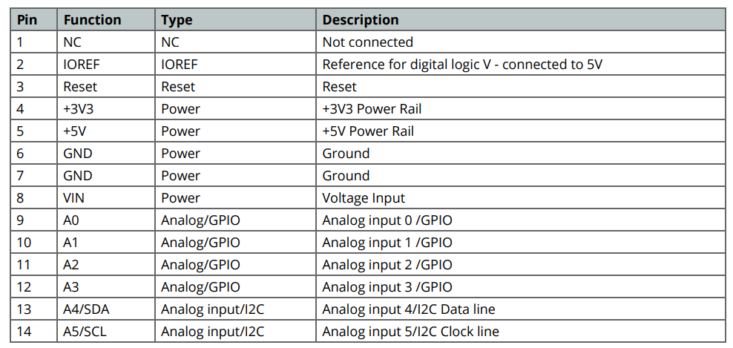

**2. JDIGITAL**

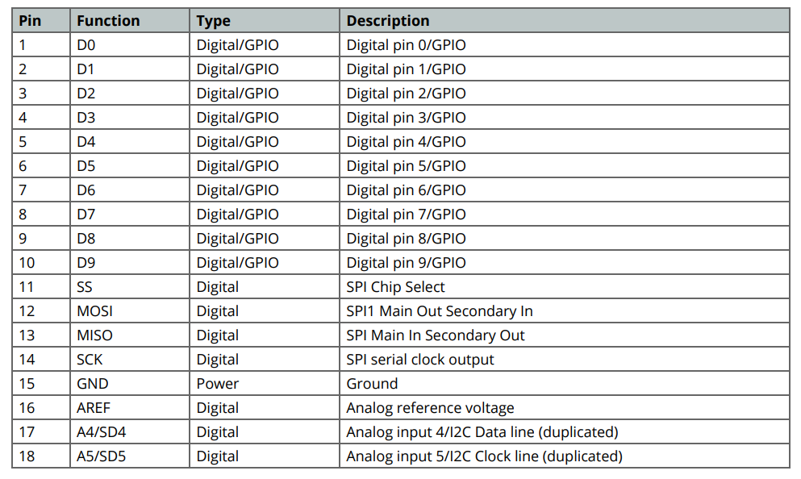

**3. Mechanical Information**

**4. Board Outline & Mounting Holes**

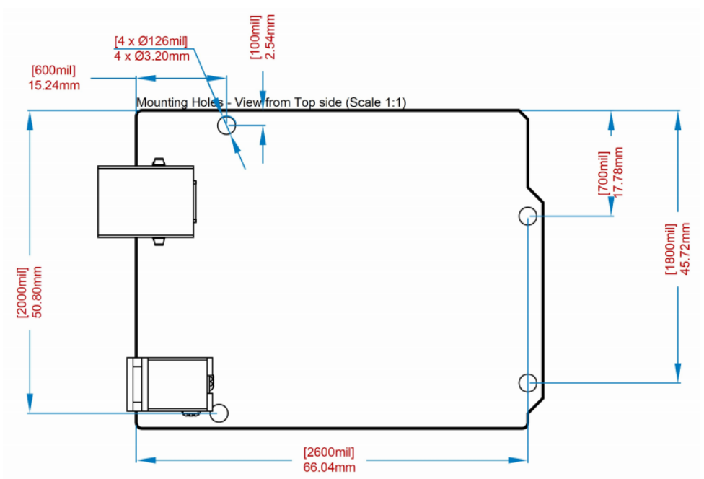

**2. I2C LCD (16 x 2)**

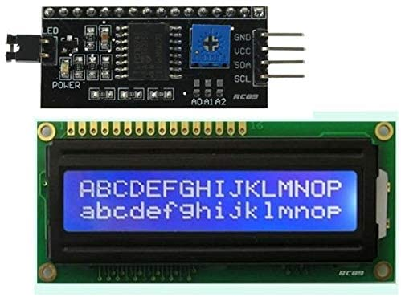

This is I2C interface 16x2 LCD display module, a high-quality 2 line 16 character LCD module with on-board contrast control adjustment, backlight and I2C communication interface. For Arduino beginners,no more cumbersome and complex LCD driver circuit connection. The real significance advantages of this I2C Serial LCD module will simplify the circuit connection, save some I/O pins on Arduino board, simplified firmware development with widely available Arduino library.

**Brief Data: -**

* Compatible with Arduino Board or other controller board with I2C bus.
* Display Type: Negative white on Blue backlight.
* I2C Address:0x38-0x3F (0x3F default)
* Supply voltage: 5V
* Interface: I2C to 4bits LCD data and control lines.
* Contrast Adjustment: built-in Potentiometer.
* Backlight Control: Firmware or jumper wire.
* Board Size: 80x36 mm

**Setting Up:**

Hitachi’s HD44780 based character LCD are very cheap and widely available, and is an essential part for any project that displays information. Using the LCD piggy-back board, desired data can be displayed on the LCD through the I2C bus. In principle, such backpacks are built around PCF8574 (from NXP) which is a general purpose bidirectional 8 bit I/O port expander that uses the I2C protocol. The PCF8574 is a silicon CMOS circuit provides general purpose remote I/O expansion (an 8-bit quasi-bidirectional) for most microcontroller families via the two-line bidirectional bus (I2C-bus). Note that most piggy-back modules are centered around PCF8574T (SO16 package of PCF8574 in DIP16 package) with a default slave address of 0x27. If your piggy-back board holds a PCF8574AT chip, then the default slave address will change to 0x3F. In short, if the piggy-back board is based on PCF8574T and the address connections (A0-A1-A2) are not bridged with solder it will have the slave address 0x27.

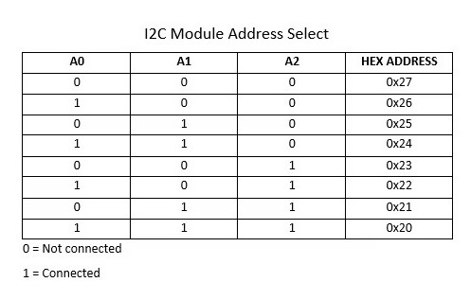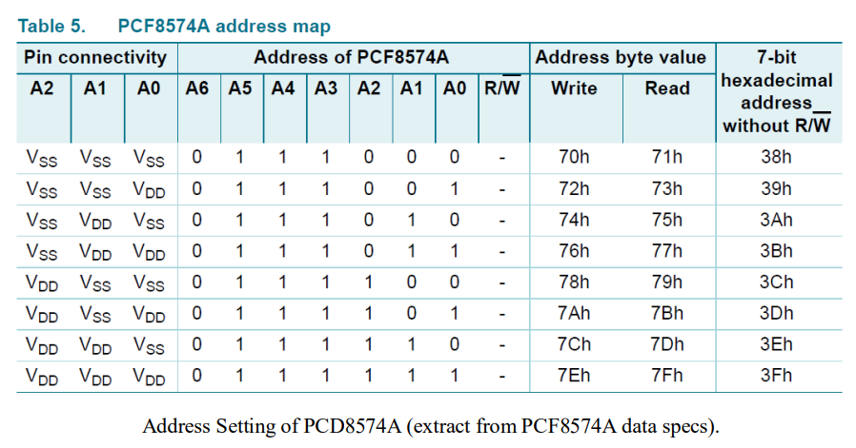

**Note: When the pad A0~A2 is open, the pin is pull up to VDD. When the pin is solder shorted, it is pull down to VSS.**

**The default setting of this module is A0~A2 all open, so is pull up to VDD. The address is 3Fh in this case.**

Reference circuit diagram of an Arduino-compatible LCD backpack is shown below. What follows next is information on how to use one of these inexpensive backpacks to interface with a microcontroller in ways it was exactly intended.

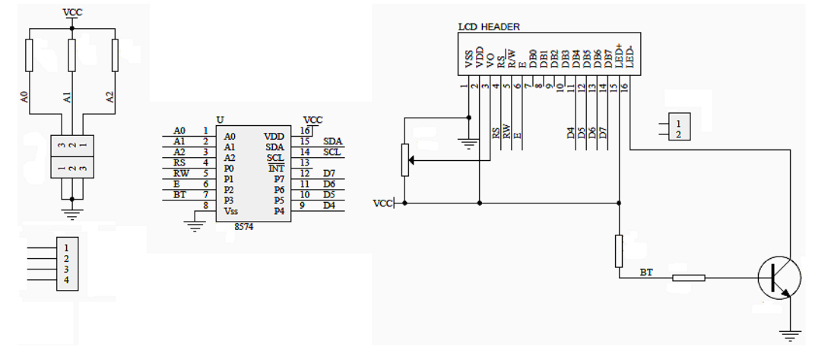

I2C LCD Display. At first you need to solder the I2C-to-LCD piggy-back board to the 16-pins LCD module. Ensure that the I2C-to-LCD piggy-back board pins are straight and fit in the LCD module, then solder in the first pin while keeping the I2C-toLCD piggy-back board in the same plane with the LCD module. Once you have finished the soldering work, get four jumper wires and connect the LCD module to your Arduino as per the instruction given below

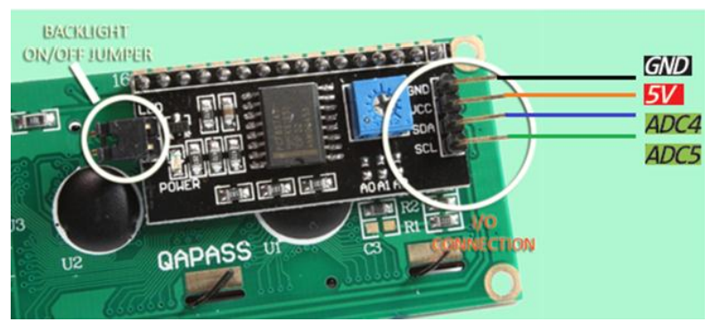

**LCD display to Arduino wiring: -**

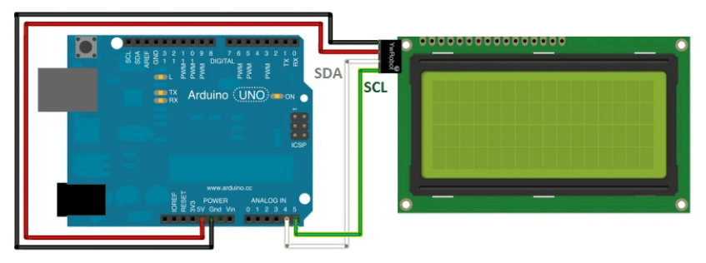

**3. IR proximity sensor**

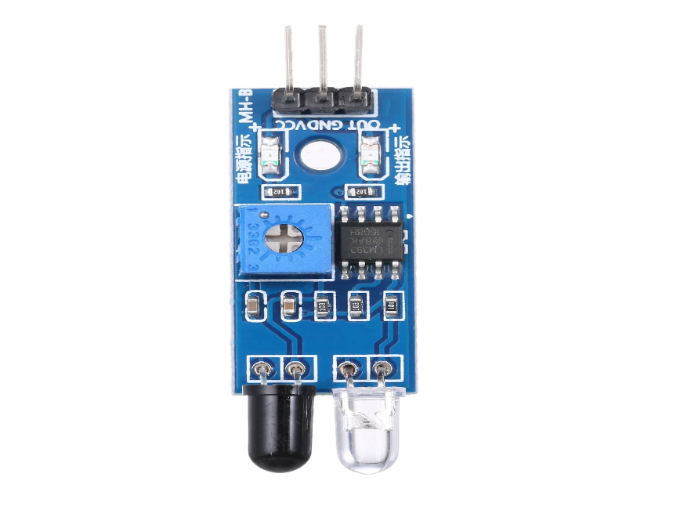

The sensor module adaptable to ambient light, having a pair of infrared emitting and receiving tubes, transmitting tubes emit infrared certain frequency, when the direction of an obstacle is detected (reflection surface), the infrared reflected is received by the reception tube, After a comparator circuit processing, the green light is on, but the signal output interface output digital signal (a low-level signal), you can adjust the detection distance knob potentiometer, the effective distance range of 2 ~ 30cm, the working voltage of 3.3V- 5V. Detection range of the sensor can be obtained by adjusting potentiometer, with little interference, easy to assemble, easy to use features, can be widely used in robot obstacle avoidance, avoidance car, line count, and black and white line tracking and many other occasions.

**Specification: -**

1. When the module detects an obstacle in front of the signal, the green indicator lights on the board level, while the OUT port sustained low signal output, the module detects the distance 2 ~ 30cm, detection angle 35 °, the distance can detect potential is adjusted clockwise adjustment potentiometer, detects the distance increases; counter clockwise adjustment potentiometer, reducing detection distance.
2. The sensor active infrared reflection detection, target reflectivity and therefore the shape is critical detection distance. Where the minimum detection distance black, white, maximum; small objects away from a small area, a large area from the Grand.
3. The sensor module output port OUT port can be directly connected to the microcontroller IO can also be directly drive a 5V relay; Connection: VCC-VCC; GND-GND; OUT-IO
4. Comparators LM393, stable;
5. The module can be 3-5V DC power supply. When the power is turned on, the red power indicator lights;
6. With the screw holes 3mm, easy fixed installation;
7. Board size: 3.2CM * 1.4CM
8. Each module has been shipped threshold comparator voltage adjusted by potentiometer good, non-special case, do not adjustable potentiometer.

**Module Interface Description: -**

1. VCC : 3.3V-5V external voltage (can be directly connected to 5v and 3.3v MCU )
2. GND : GND External
3. OUT : small board digital output interface (0 and 1)

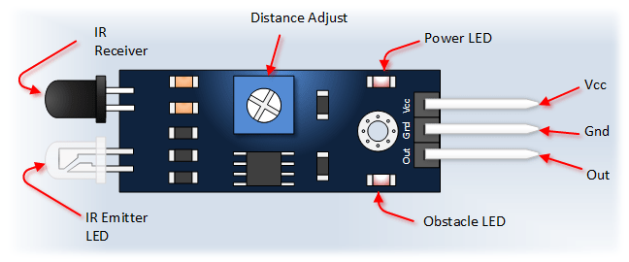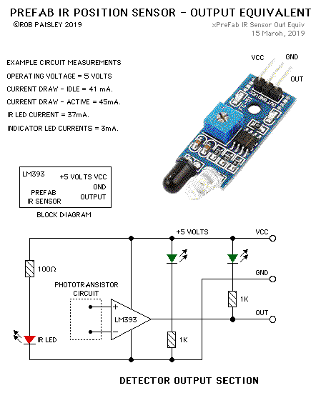

**4. Servo motor (SG90)**

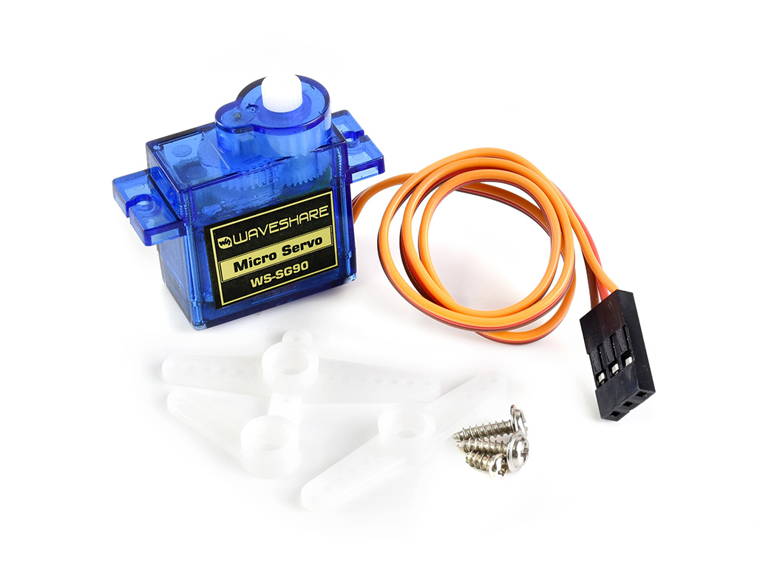

Tiny and lightweight with high output power. Servo can rotate approximately 180 degrees (90 in each direction), and works just like the standard kinds but smaller. You can use any servo code, hardware or library to control these servos. Good for beginners who want to make stuff move without building a motor controller with feedback & gear box, especially since it will fit in small places. It comes with a 3 horns (arms) and hardware.

**Specifications: -**

* Weight: 9 g
* Dimension: 22.2 x 11.8 x 31 mm approx.
* Stall torque: 1.8 kgf·cm
* Operating speed: 0.1 s/60 degree
* Operating voltage: 4.8 V (~5V)
* Dead band width: 10 μs
* Temperature range: 0 ºC – 55 ºC Position "0" (1.5 ms pulse) is middle, "90" (~2ms pulse) is all the way to the left. ms pulse) is all the way to the right, ""-90" (~1ms pulse) is all the way to the left.

**Additional Specifications: -**

* Rotational Range: 180°
* Pulse Cycle: ca. 20 ms
* Pulse Width: 500-2400 µs

**Basic Information: -**

* Modulation: Analog
* Torque: 4.8V: 25.0 oz-in (1.80 kg-cm)
* Speed: 4.8V: 0.10 sec/60°
* Weight: 0.32 oz (9.0 g)
* Dimensions:
* Length: 0.91 in (23.1 mm)
* Width: 0.48 in (12.2 mm)
* Height:1.14 in (29.0 mm)
* Motor Type: 3-pole
* Gear Type: Plastic Rotation/Support: Bushing

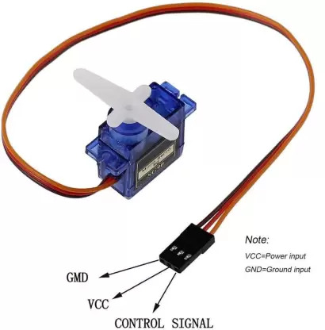

**Proteus design: -**

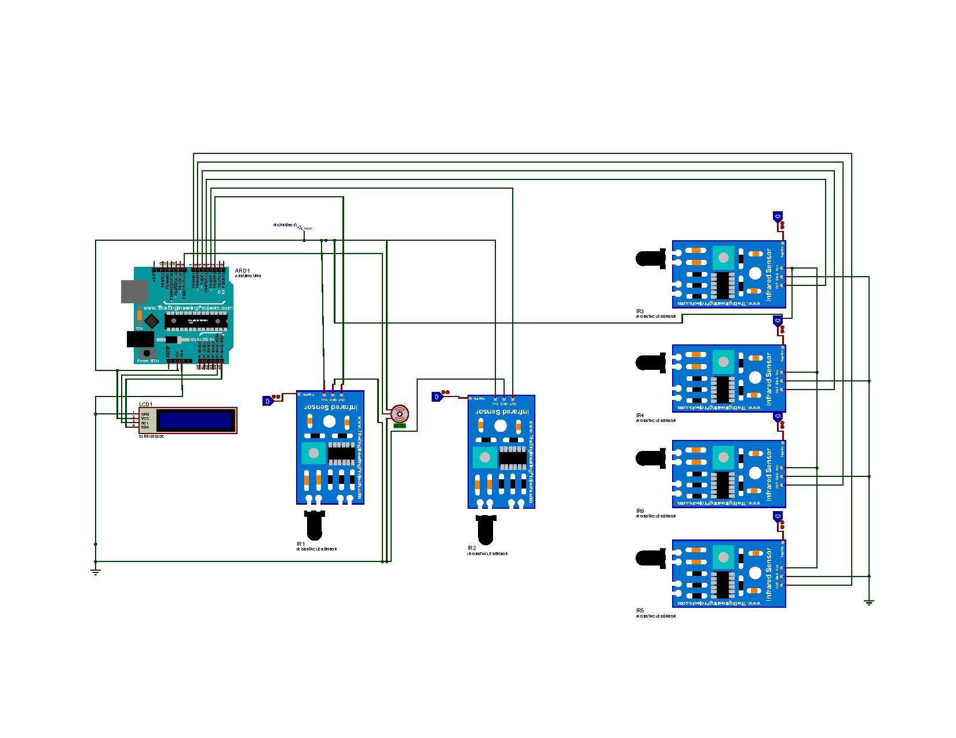

**Operation flow chart: -**

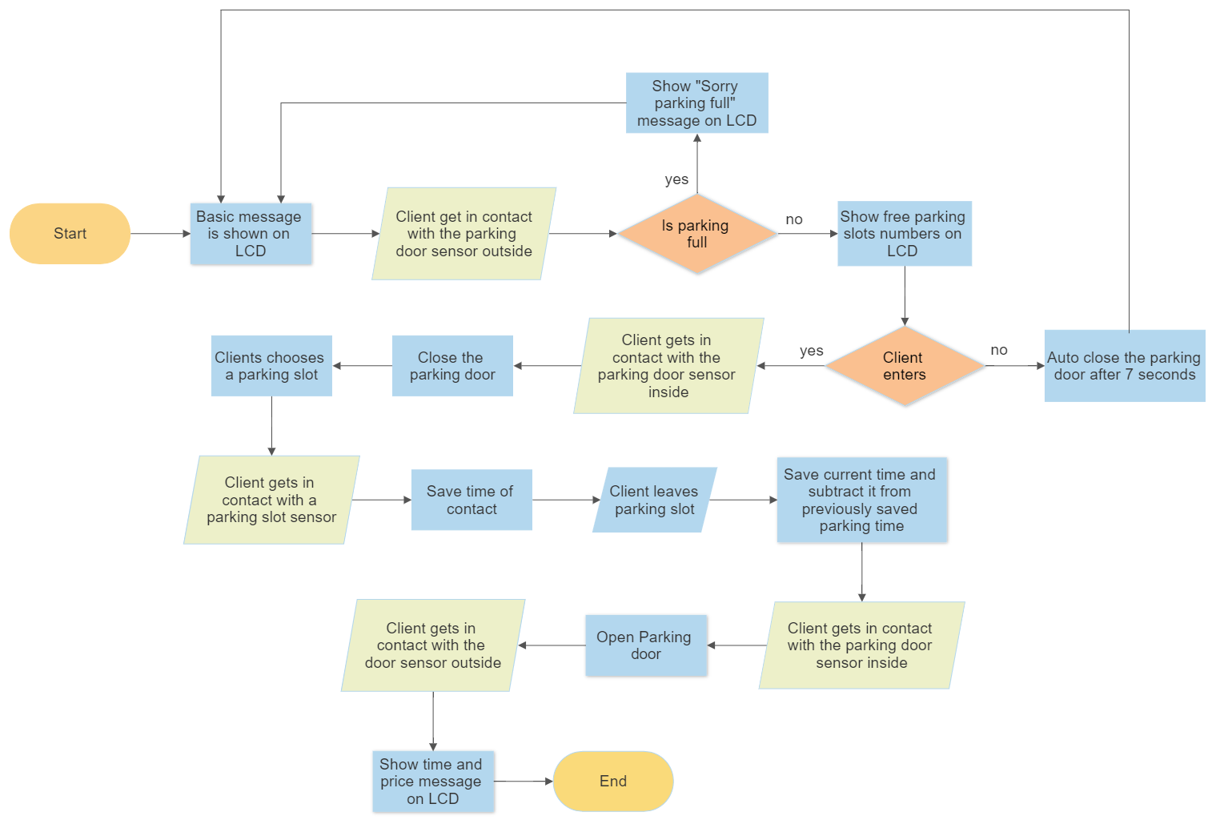

**Real project photos: -**

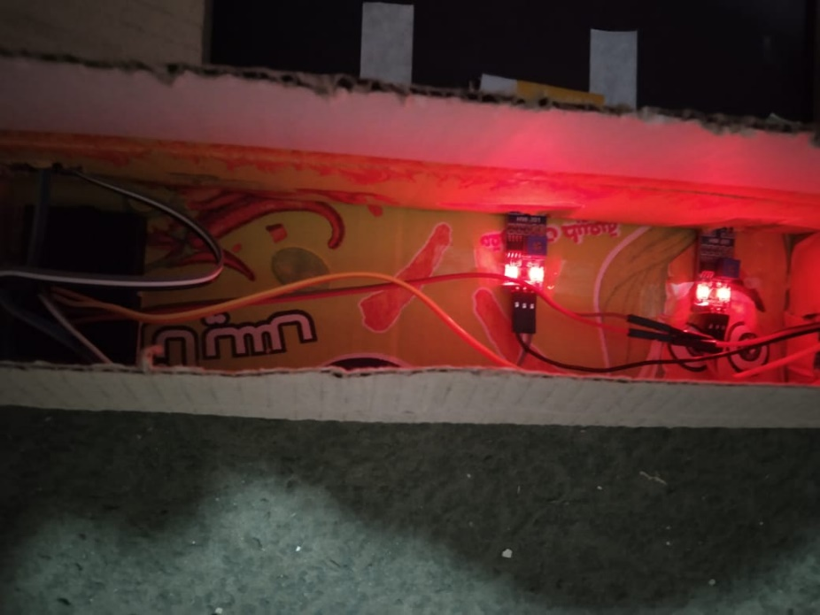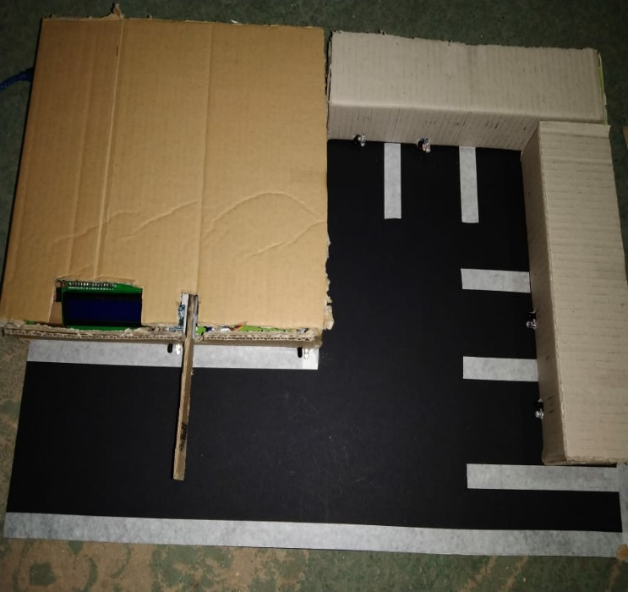

**(A) (B)**

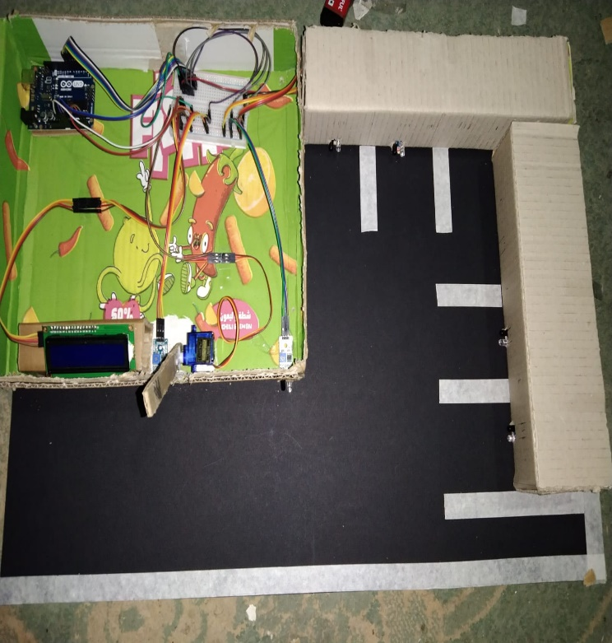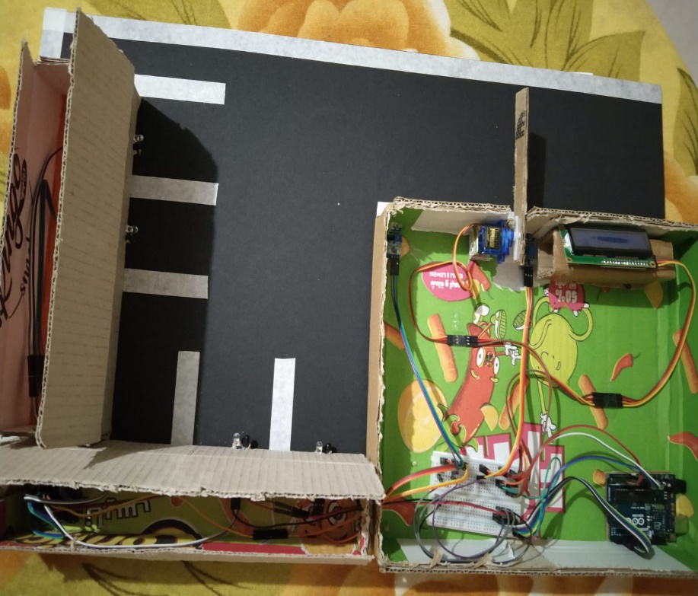

**(C) (D)**

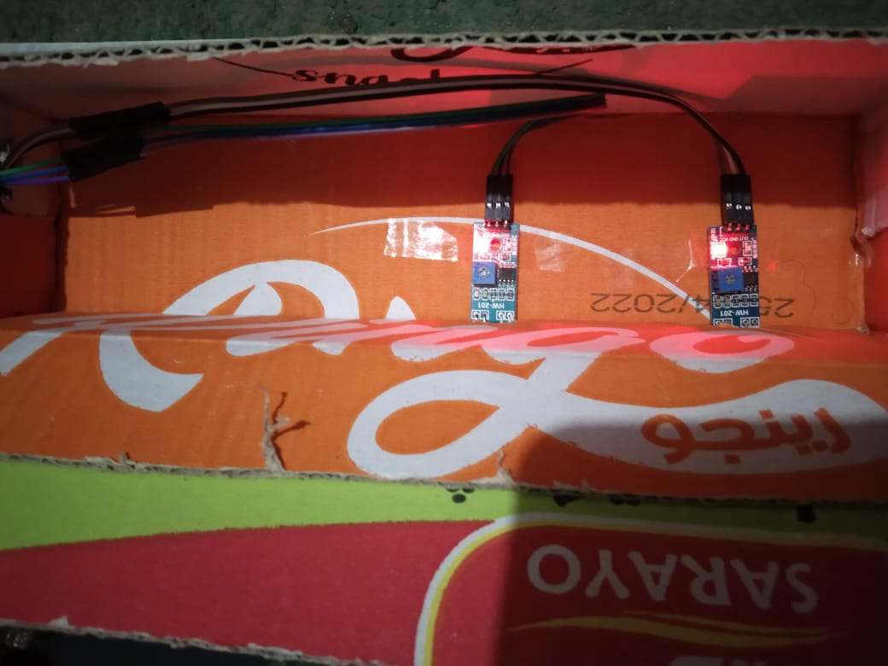

**(E)**